Friends of the Pet Cemetery
Shooters Hill Road London SE18 4LX

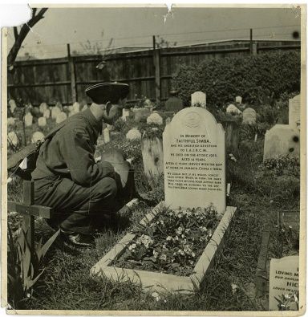
News Letter No 3
September 2018

Much has happened at the Old Blue Cross Pet Cemetery since the last newsletter. The committee and volunteers work tirelessly to keep the site clean and tidy, sometimes not easy with two large Hornbeam trees in the centre which seem to grow more leaves every year which are then deposited on the ground.
Our Clean up Days always start with a big sweep up four or five brooms and a leaf blower in operation!
And then of course the weeding, a gardener’s work is never done.

Looking at the flower beds and rockeries it had become obvious that something would have to be done to the larger rockery at the end of the Trellis Arch bed; the occasional geranium struggles to grow there as the area bakes in the fullness of the sun on the south facing corner. The plan was to have a Memorial
as a tribute to all animals who have given their lives in conflict in the service of their country, This was going to be expensive, so the fund raising began with the Chairperson giving power point presentations and the committee attending various events across the borough to promote aware of the Pet Cemetery, but we recognised this would be a long process and possibly not achievable.

Earlier in the year the year the decision was made to apply for a Tesco Bags of Help Grant.
The form filling seemed endless, but we sent it off and at the beginning of June heard that we were one of the three charities selected for the August collection where shoppers place the blue tokens in the bin of the charity of their choice. On Tuesday the 25th September we heard that we had been successful,
The shoppers of London SE18 had chosen the Pet Cemetery as the charity they wished to support. We are naturally delighted and can now go ahead with landscaping the rockery and erecting a memorial lectern similar to the one in the picture gallery on the website.

Further achievements from the last news letter
Stone cleaning: this has now been completed and many of the stones previously illegible can now be
read. One of the jobs now is to carry out rubbings on the stones that might possibly
reveal their inscriptions.
Memorial wall: there are now 21 plaques on the wall.

Our thanks go to ongoing support from:
Royal Borough of Greenwich Parks Estates and Open Spaces
Thompsons Garden Centre Welling Manager Andrew Martinovs
Volunteers from the community 10,000 team
Members of the Community

Liz McDermott Chair FOPC mcdermott_liz@hotmail.com 07815558680 0208 8545172

